WHAT WE DO — COMMUNITY SERVICES
Strengthening Communities Through Meaningful Action
For ASSF, service extends beyond the preservation of heritage. It also means responding to practical community needs—especially where access to healthcare, education and essential support can be limited.
Our documented community initiatives have focused on healthcare and health awareness, education support, and humanitarian assistance during times of crisis. Each intervention has been rooted in understanding a need on the ground and working with local partners and volunteers to respond with dignity and purpose.
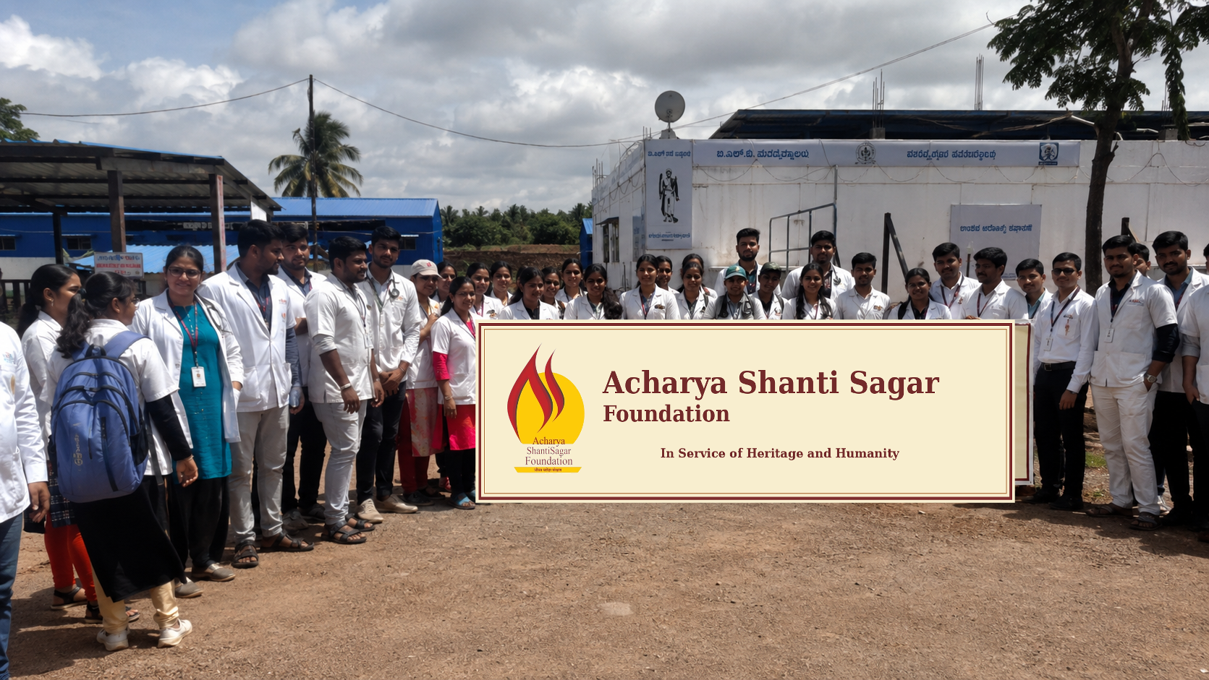
Original ASSF health-camp photograph, with the physical event banner corrected to show the supplied Acharya Shanti Sagar Foundation logo and exact Foundation name.

Community at the Centre
Communities are not simply beneficiaries of a service. They are the people who sustain local institutions, traditions and everyday social life. Strengthening their wellbeing is therefore an important part of ASSF’s broader commitment to heritage and humanity.
Our community work has taken different forms because community needs are different. A health camp can bring essential medical attention closer to a village. Educational support can help children access the basic materials they need to learn. During an emergency, timely food and essential supplies can help families through a difficult period.

Healthcare & Health Awareness

Taking Essential Healthcare Closer to Rural Communities
Access to timely healthcare can be difficult for communities in remote and economically vulnerable areas. ASSF has organised and supported free medical and health-awareness camps, bringing doctors, specialists and diagnostic services closer to people in rural communities.
The documented camps covered general health, paediatric, cardiac, ophthalmic, dental, orthopaedic and other specialist consultations, along with diagnostic screening and health awareness. Depending on the camp, services included blood sugar, haemoglobin, blood pressure, ECG and Echo testing, eye screening and other assessments. Medicines were provided where required, and patients needing specialised care were referred for further treatment.
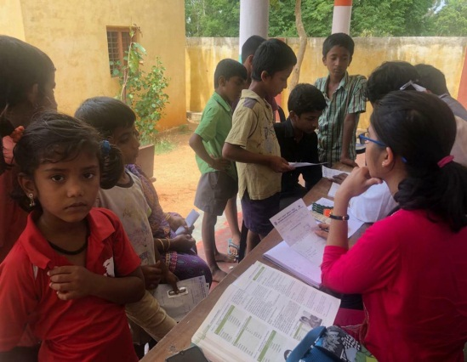
rural health screening and consultation.
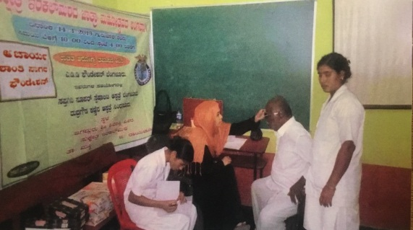
health consultation at a community medical camp.

Early Diagnosis, Treatment and Follow-up
The purpose of these camps was not limited to a one-day consultation. They were designed to identify health concerns early, provide immediate guidance and connect people with further treatment where necessary.
At the Yarnal health camp, around 1,800 people from surrounding villages benefited. The camp included multiple specialist consultations and diagnostic tests; 78 cataract cases were identified and subsequently underwent free cataract surgery at Belagavi. Patient records were also maintained for follow-up.
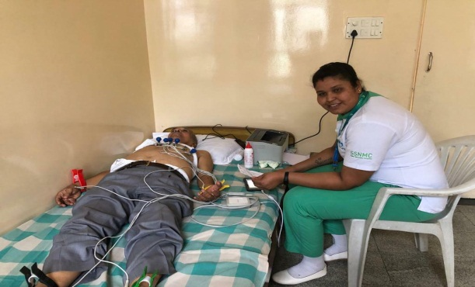
blood donation and health-service activity.

Education & Student Support

Helping Children Continue to Learn
Education begins with access to the basics. ASSF studied schools in and around Yarnal and identified three schools serving children from economically disadvantaged backgrounds. Nearly 500 students were provided with books and stationery materials.
The approach was practical: understand the needs of the schools and students first, then provide support that can be used immediately.
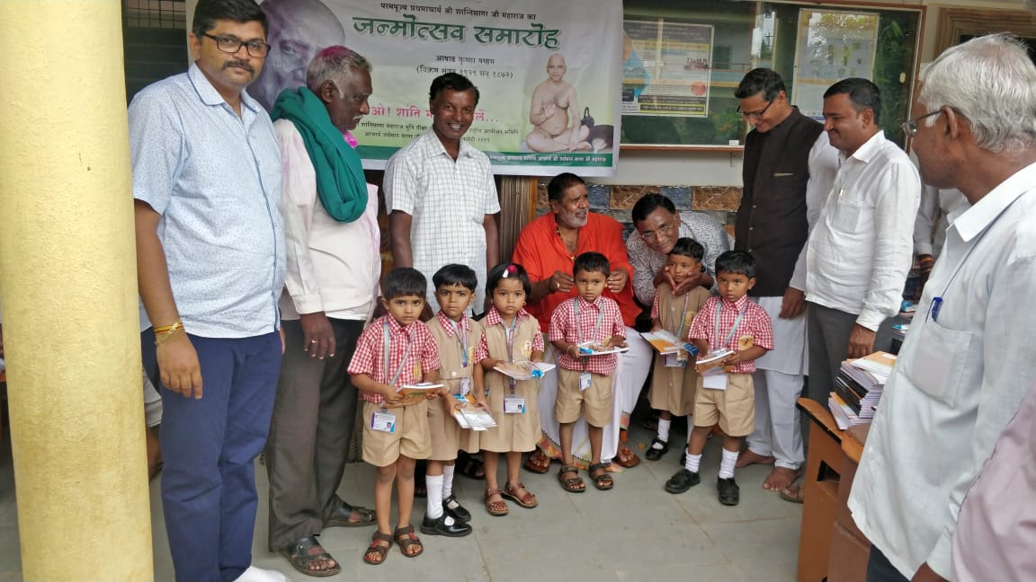
distribution of educational materials to students.

Emergency & Humanitarian Relief

Standing With Communities in Times of Crisis
Some needs cannot wait. When communities face floods or other emergencies, timely access to food and essential supplies becomes critical.
During the North Karnataka floods, ASSF responded with essential relief supplies for affected families. With the support of volunteers and local networks, 2,000 food kits and 500 kits containing a blanket and towel were distributed to people affected by the floods. The kits were personally handed over to individuals to help ensure that assistance reached those who needed it.

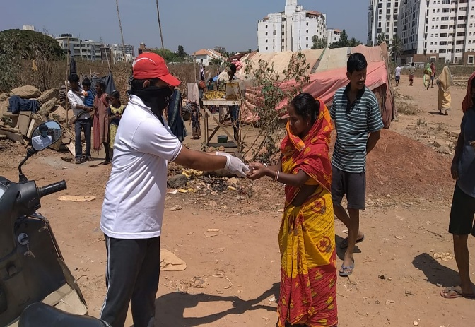
distribution of relief assistance.

Responding During the COVID-19 Crisis
During the COVID-19 pandemic, ASSF joined with several Digambar Jain associations and community partners under the banner of Sakal Digambar Jain Samaj, Bengaluru, to support people affected by the crisis.
From 1 April to 3 May 2020, cooked meal packets were distributed across Bengaluru to people in slums and migrant communities, while essential food-grain kits were distributed to families in need. The documented programme recorded 777,534 meal packets served and 2,795 food-grain kits distributed.
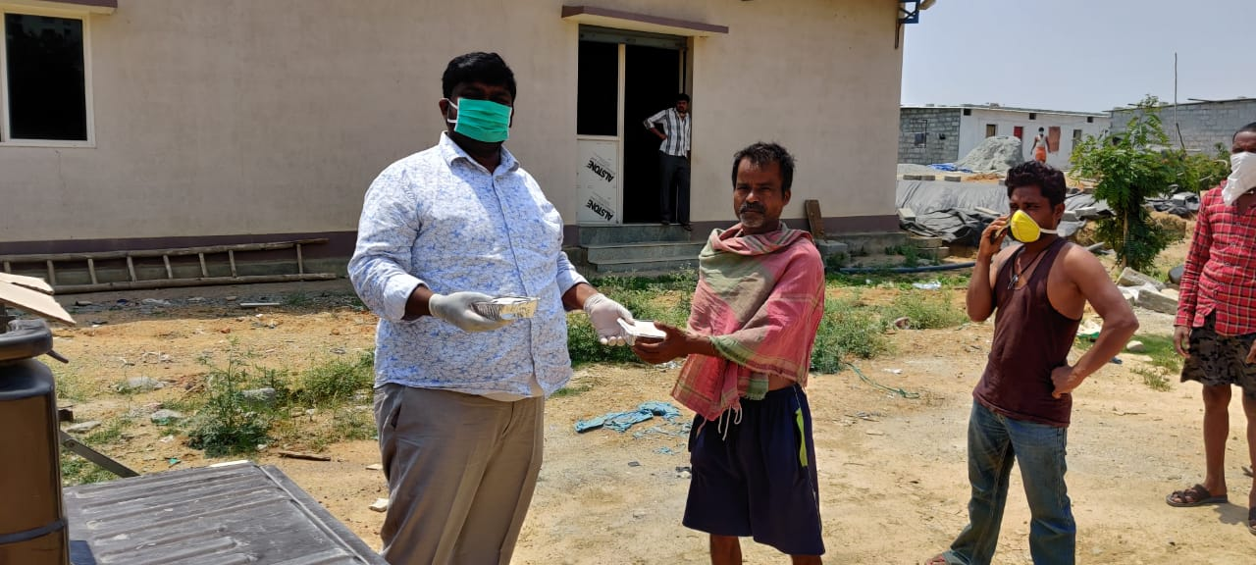
Original ASSF photograph — community relief distribution during the COVID-19 response.
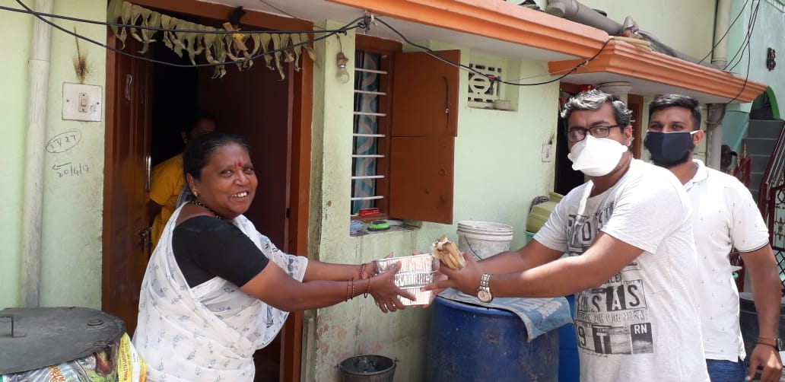
Original ASSF photograph — direct distribution of essential support.

How We Work With Communities
Across these initiatives, our approach has remained practical and community-oriented:

01 — Understand
Identify the need through direct engagement with local institutions and communities.

02 — Respond
Provide practical support that addresses the identified need.

03 — Collaborate
Work with doctors, hospitals, educational institutions, volunteers, community organisations and local networks.

04 — Reach
Take assistance closer to communities that may otherwise have limited access.

05 — Follow Through
Where further care or support is required, help connect people with the appropriate next step.

A Broader Commitment to Service
ASSF’s community-service work reflects a simple belief: meaningful service begins with listening to communities and responding to what is needed on the ground.
Today, manuscript conservation is the Foundation’s principal programme. Our community initiatives remain an important part of the Foundation’s broader commitment to people and to the communities in which our work takes place.
Preserving heritage. Supporting communities. Serving with purpose.
In Service of Heritage and Humanity

